

POINT OF SALE MANAGEMENT SYSTEM

**Members:**

Muhammad Arsalan Warsi

(SP19-BSSE-0030 | [sp19bsse0030@maju.edu.pk](mailto:sp19bsse0030@maju.edu.pk))

Aliyan Ahmed

(SP19-BSSE-0028 | [sp19bsse0028@maju.edu.pk](mailto:sp19bsse0028@maju.edu.pk))

Muhammad Hamza Taimoor

(SP19-BSSE-0011 | [sp19bsse0011@maju.edu.pk](mailto:sp19bsse0011@maju.edu.pk))

**Submitted To:**

Sir Muhammad Tauseef

Software Construction and Development (BM)

Table of Contents

INTRODUCTION 5

Background: 5

Scope of Project: 5

Objectives of Project: 5

Features of Project: 6

ANALYSIS & DESIGN 6

Requirement Analysis: 6

Project Requirements: 7

End User Requirements: 8

Administrator Requirements: 8

Gantt Chart: 8

SYSTEM DESIGN 9

Use Case Diagram: 9

ERD Diagram: 10

Database Queries: 10

TOOLS AND TECHNOLOGIES 14

Microsoft Visual Studio: 14

Microsoft SQL Server: 14

Language Selection: 14

APPLICATION IMPLEMENTATIONS 14

Code Structure: 14

Project Screen Shots: 14

Testing and Debugging: 25

CONCLUSION 28

Project Limitations: 28

Conclusions: 28

Future Directions: 28

RECOMMENDATION

The Following are the recommendation that is required to use new design system effectively:

* The Hardware and the Software requirements must be specified.
* The Staff must know the basic knowledge of Computer Operations.
* The Staff must be trained for the job, and no special training is needed to achieve the full implementation.

DECLARATION

We hereby declare that the point-of-sale management system project is our own work. As far as we know, it has not been submitted to any degree or examination and other universities, and all sources of this project we use or quote have passed complete references Information for instructions and confirmation.

CERTIFICATE OF APPROVAL

This Project “Point of Sale Management System” has been approved by our teacher “Sir Muhammad Tauseef” teaching in the Department of Computer Science, Faculty of Software Construction and Development at Muhammad Ali Jinnah University.

ACKNOWLEDGEMENT

I thank Allah Almighty for his guidance, protection, wisdom, knowledge and understanding throughout my learning process. The success of the completion of the task would be incomplete without thanks to the people whose guidance and support can make this work successful.

We would also like to thank Muhammad Ali Jinnah University for designing such a detailed syllabus and allowing us to complete this project. Last but not least, we thank every direct and indirect person who participated in the project. We have gained a good experience by doing this project, where we learned and experienced many beneficial and useful things.

LIST OF FIGURES

FIGURE 1.1 Background …………………………………………………………………………

FIGURE 1.2 Scope of Project ………………………………………………………………….

FIGURE 1.3 Objective of Project ………………………………………………………….…

FIGURE 1.4 Features of Project ……………………………………………………………..

FIGURE 2.1 Requirement Analysis ………………………………………………………….

FIGURE 2.2 Project Requirement …………………………………………………………..

FIGURE 2.3 End User Requirement ………………………………………………………..

FIGURE 2.4 Administrator requirement …………………………………………………

FIGURE 2.5 Gantt chart ………………………………………………………………………....

FIGURE 3.1 Use case diagram ………………………………………………………………..

FIGURE 3.2 ERD diagram ………………………………………………………………………..

FIGURE 3.3 Database Queries ………………………………………………………………..

FIGURE 4.1 Microsoft Visual Studio ………………………………………………………..

FIGURE 4.2 Microsoft SQL Server ……………………………………………………………

FIGURE 4.3 Language Selection ……………………………………………………………….

FIGURE 5.1 Code Structure ……………………………………………………...................

FIGURE 5.2 Project Screen Shots ……………………………………………………………..

FIGURE 5.3 Testing and Debugging ………………………………………………………….

FIGURE 6.1 Project Limitations ………………………………………………………………...

FIGURE 6.2 Conclusions ……………………………………………………………………………

FIGURE 6.3 Future Directions …………………………………………………………………..

FIGURE 6.4 References …………………………………………………………………………….

LIST OF ABBREVATION

POS Point of Sale

DBMS Database Management System

GC Gantt Chart

UCD Use Case Diagram

ERD Entity Relationship Diagram

DML Data Manipulation Language

DDL Data Definition Language

CLR Common Language Runtime

MVS Microsoft Visual Studio

SQL Structure Query Language

# **INTRODUCTION**

## Background:

The Marts are facing many problems in managing and selling the stock available at the store due to manual paperwork by the employees working in the store. At the end of the day, a few employees are reserved to note the available quantity of each product in the store, which spends a lot of time, human error of manual reporting items and increases employees' pay. On the other hand, reporting problems are also occurring at the sales counter due to human error in manual receipt generation, price calculation of sales receipts, and time. The manual work at store also restricts the customer to pay the bill from card or e-wallet they can only pay the cash instead of product. The customer who visits the store has to wait a long time for the process of the receipt generation.

## Scope of Project:

The Point-of-Sale management system helps to reduce the number of employees working in the mart or store that gives direct impact to reduce the salaries of employees (cost). No need for extra employees that manage the stock, the system will automatically generate the reports of the available stock in the store. It also benefits the buyer to reduce the human errors in the sales because it fetches the price from the database and also updates the data according to the sales and stock.

This software helps to improve recoding the sales reports and product management methods to reduce the employee's cost by 10% and improve mart sales by 25%. The store can achieve by implementing the system that helps to manage all the thing and need fewer employees to work on it.

## Objectives of Project:

The aims and objectives of this project is to design and implement a computerized Point of Sale system that reduce the amount of the salaries paid to the employees that are hired for managing the stock, reduce the time of sales receipt generation and allow the customers to pay the bill from card and e-wallet which helps to increase the sales of the mart.

Features of Project:

* The Point-of-Sale system is able to generate a report on daily, monthly and yearly basis which can easily understand the success of their business.
* A system should be able to manage the data of all users. The system should be able to handle user login and logout accurately.
* The system should be able to add new stock or product details easily to the database. Details like price, quantity etc.
* The system can update and delete stock or product and details of the product easily from the database.
* The system can handle the payments by adding the price and quantity of total products and should be also to handle any discount coupon and exclude the amount of coupon from total price.
* The system is able to print the sales receipt after the customer successfully pay the amount.
* The system allows the user to search the product and see the detail of the product like price, quantity etc.

# **ANALYSIS & DESIGN**

## Requirement Analysis:

Functional Requirements:

* A system should be able to manage the data of all users. The system should be able to handle user login and logout accurately.
* All the users have different right in the system. Admin can add the staff person or the customers.
* The system is capable to restore or update the new password of existing users by providing some legal details. The password is update only by conforming the details of users.
* The new stock or product details can be easily added to the database. Details like price, quantity etc.
* The stock or product details can be easily update or delete from the database. Update details like change in price, remaining quantity of product etc. and delete the product or stock that is ended by the company.
* The system is able to perform the payments. The payment is done by adding the price and quantity of total products.
* The system can accept payment in the form of cash, credit or debit card and also from e wallet.
* The system is able to print the sales receipt after the customer successfully pay the amount.
* The system can generate reports of sales, products, customer, and customer services.
* The system is capable to search the product according to the customer needs.

Non-Functional Requirements:

* The system can store the stock in to database safely and accurately without any changes in detail of the product.
* The system should be run on all personal computer that are installed in the store or mart.
* The system is enough fast to perform the task in less than a sec to avoid the delay for customers and also for staff while adding the product.
* All the payments that are done must be secure and verified. If the user is paying by card, he or she must have balance in the account, or if he/ she online pay the payment should be received first.
* Only the admin and staff have a right to access the system for view or generate the report of sales, services, or stock.
* The feasibility of the system is high / best (Error Free Software).
* The system has user friendly graphical interface representation.

## Project Requirements:

* The one UI designer in required to create the design of the system.
* The one database designer and developer is required.
* The two .NET developers are need to develop and integrate the system.
* The testing needs to be done to check the any errors or in complete requirements in the system.
* Hardware for the development of the system.
* Tool needed in the development of the system.

## End User Requirements:

* Customer have a receipt after payment.
* The sales person can handle the sales like price of product, total product, discount to total bill.
* The sales person can add or delete the product in the list if user is satisfied or not from the product or price of the product.
* The system allows the user to search the product and see the detail of the product like price, quantity etc.
* Customers are able to perform payments from different methods like cash, card, e wallet.
* The admin can only add the new user to the system and only have right to update the password of the staff.

## Administrator Requirements:

* The admin can only add the new user to the system.
* The admin only has right to update the password of the staff.
* The admin can generate reports of sales, products, customer, and customer services.
* The admin can add new stock or product details to the database.
* The admin can update or delete the stock or product details from the database.

## Gantt Chart:

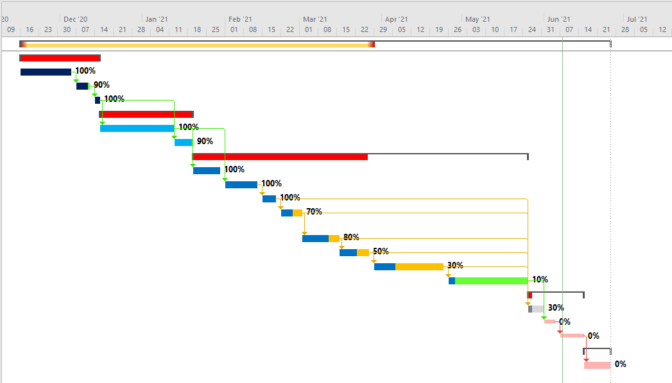

**SYSTEM DESIGN**

## Use Case Diagram:

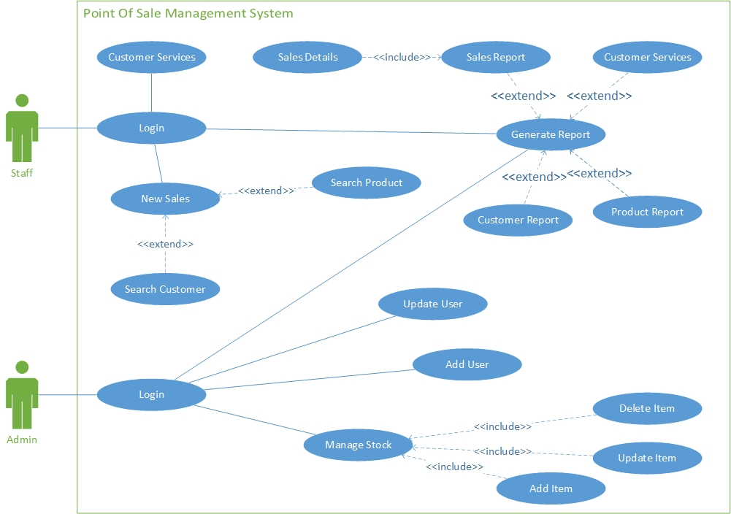

## ERD Diagram:

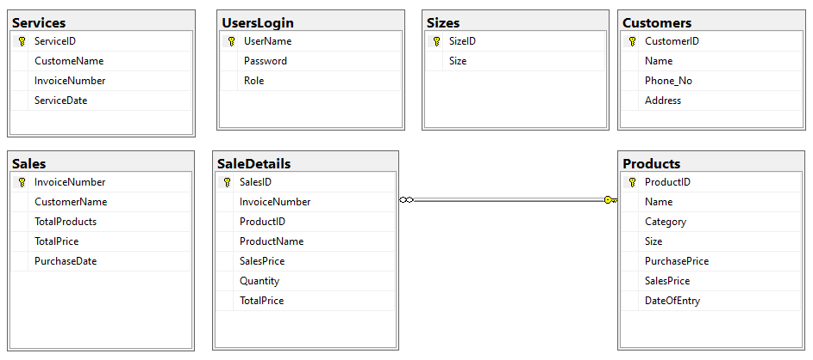

## Database Queries:

Customer Table:

SET ANSI_NULLS ON

GO

SET QUOTED_IDENTIFIER ON

GO

CREATE TABLE [dbo].[Customers](

[CustomerID] [int] IDENTITY(1,1) NOT NULL,

[Name] [nvarchar](50) NULL,

[Phone_No] [nvarchar](17) NULL,

[Address] [nvarchar](200) NULL,

CONSTRAINT [PK_Customers] PRIMARY KEY CLUSTERED

(

[CustomerID] ASC

)WITH (PAD_INDEX = OFF, STATISTICS_NORECOMPUTE = OFF, IGNORE_DUP_KEY = OFF, ALLOW_ROW_LOCKS = ON, ALLOW_PAGE_LOCKS = ON, OPTIMIZE_FOR_SEQUENTIAL_KEY = OFF) ON [PRIMARY]

) ON [PRIMARY]

GO

Products Table:

SET ANSI_NULLS ON

GO

SET QUOTED_IDENTIFIER ON

GO

CREATE TABLE [dbo].[Products](

[ProductID] [int] IDENTITY(1,1) NOT NULL,

[Name] [varchar](70) NULL,

[Category] [nvarchar](20) NULL,

[Size] [nvarchar](50) NULL,

[PurchasePrice] [decimal](18, 2) NULL,

[SalesPrice] [decimal](18, 2) NULL,

[DateOfEntry] [date] NULL,

CONSTRAINT [PK_Products] PRIMARY KEY CLUSTERED

(

[ProductID] ASC

)WITH (PAD_INDEX = OFF, STATISTICS_NORECOMPUTE = OFF, IGNORE_DUP_KEY = OFF, ALLOW_ROW_LOCKS = ON, ALLOW_PAGE_LOCKS = ON, OPTIMIZE_FOR_SEQUENTIAL_KEY = OFF) ON [PRIMARY]

) ON [PRIMARY]

GO

SaleDetails Table:

SET ANSI_NULLS ON

GO

SET QUOTED_IDENTIFIER ON

GO

CREATE TABLE [dbo].[SaleDetails](

[SalesID] [bigint] IDENTITY(1,1) NOT NULL,

[InvoiceNumber] [bigint] NULL,

[ProductID] [int] NULL,

[ProductName] [nvarchar](70) NULL,

[SalesPrice] [decimal](18, 2) NULL,

[Quantity] [int] NULL,

[TotalPrice] [decimal](18, 2) NULL,

CONSTRAINT [PK_SaleDetails] PRIMARY KEY CLUSTERED

(

[SalesID] ASC

)WITH (PAD_INDEX = OFF, STATISTICS_NORECOMPUTE = OFF, IGNORE_DUP_KEY = OFF, ALLOW_ROW_LOCKS = ON, ALLOW_PAGE_LOCKS = ON, OPTIMIZE_FOR_SEQUENTIAL_KEY = OFF) ON [PRIMARY]

) ON [PRIMARY]

GO

ALTER TABLE [dbo].[SaleDetails] WITH CHECK ADD CONSTRAINT [FK_ProductID] FOREIGN KEY([ProductID])

REFERENCES [dbo].[Products] ([ProductID])

ON UPDATE CASCADE

ON DELETE SET NULL

GO

ALTER TABLE [dbo].[SaleDetails] CHECK CONSTRAINT [FK_ProductID]

GO

Sales Table:

SET ANSI_NULLS ON

GO

SET QUOTED_IDENTIFIER ON

GO

CREATE TABLE [dbo].[Sales](

[InvoiceNumber] [bigint] NOT NULL,

[CustomerName] [nvarchar](50) NULL,

[TotalProducts] [int] NULL,

[TotalPrice] [decimal](18, 2) NULL,

[PurchaseDate] [date] NULL,

PRIMARY KEY CLUSTERED

(

[InvoiceNumber] ASC

)WITH (PAD_INDEX = OFF, STATISTICS_NORECOMPUTE = OFF, IGNORE_DUP_KEY = OFF, ALLOW_ROW_LOCKS = ON, ALLOW_PAGE_LOCKS = ON, OPTIMIZE_FOR_SEQUENTIAL_KEY = OFF) ON [PRIMARY]

) ON [PRIMARY]

GO

Services Table:

SET ANSI_NULLS ON

GO

SET QUOTED_IDENTIFIER ON

GO

CREATE TABLE [dbo].[Services](

[ServiceID] [int] IDENTITY(1,1) NOT NULL,

[CustomeName] [nvarchar](50) NULL,

[InvoiceNumber] [bigint] NULL,

[ServiceDate] [date] NULL,

CONSTRAINT [PK_Services] PRIMARY KEY CLUSTERED

(

[ServiceID] ASC

)WITH (PAD_INDEX = OFF, STATISTICS_NORECOMPUTE = OFF, IGNORE_DUP_KEY = OFF, ALLOW_ROW_LOCKS = ON, ALLOW_PAGE_LOCKS = ON, OPTIMIZE_FOR_SEQUENTIAL_KEY = OFF) ON [PRIMARY]

) ON [PRIMARY]

GO

Sizes Table:

SET ANSI_NULLS ON

GO

SET QUOTED_IDENTIFIER ON

GO

CREATE TABLE [dbo].[Sizes](

[SizeID] [int] IDENTITY(1,1) NOT NULL,

[Size] [nvarchar](50) NULL,

CONSTRAINT [PK_Sizes] PRIMARY KEY CLUSTERED

(

[SizeID] ASC

)WITH (PAD_INDEX = OFF, STATISTICS_NORECOMPUTE = OFF, IGNORE_DUP_KEY = OFF, ALLOW_ROW_LOCKS = ON, ALLOW_PAGE_LOCKS = ON, OPTIMIZE_FOR_SEQUENTIAL_KEY = OFF) ON [PRIMARY]

) ON [PRIMARY]

GO

User Login Table:

SET ANSI_NULLS ON

GO

SET QUOTED_IDENTIFIER ON

GO

CREATE TABLE [dbo].[UsersLogin](

[UserName] [varchar](50) NOT NULL,

[Password] [varchar](30) NULL,

[Role] [nvarchar](50) NULL,

PRIMARY KEY CLUSTERED

(

[UserName] ASC

)WITH (PAD_INDEX = OFF, STATISTICS_NORECOMPUTE = OFF, IGNORE_DUP_KEY = OFF, ALLOW_ROW_LOCKS = ON, ALLOW_PAGE_LOCKS = ON, OPTIMIZE_FOR_SEQUENTIAL_KEY = OFF) ON [PRIMARY]

) ON [PRIMARY]

GO

# **TOOLS AND TECHNOLOGIES**

## Microsoft Visual Studio:

Visual Studio is used to develop console applications and graphical user interface applications, as well as Windows Forms applications, websites and Web applications, including native code and management support for Microsoft Window, Windows mobile, windows CE, .NET framework and Microsoft Silverlight.

## Microsoft SQL Server:

SQL Server is a database server, its function is to store and retrieve data, and when the request is sent to other applications. SQL Server helps us optimize and maintain server performance while ensuring its recoverability and availability.

## Language Selection:

We choose C# language to develop this project.

**APPLICATION IMPLEMENTATIONS**

## Code Structure:

The code file of the system is attached with this document.

## Project Screen Shots:

Login Form:

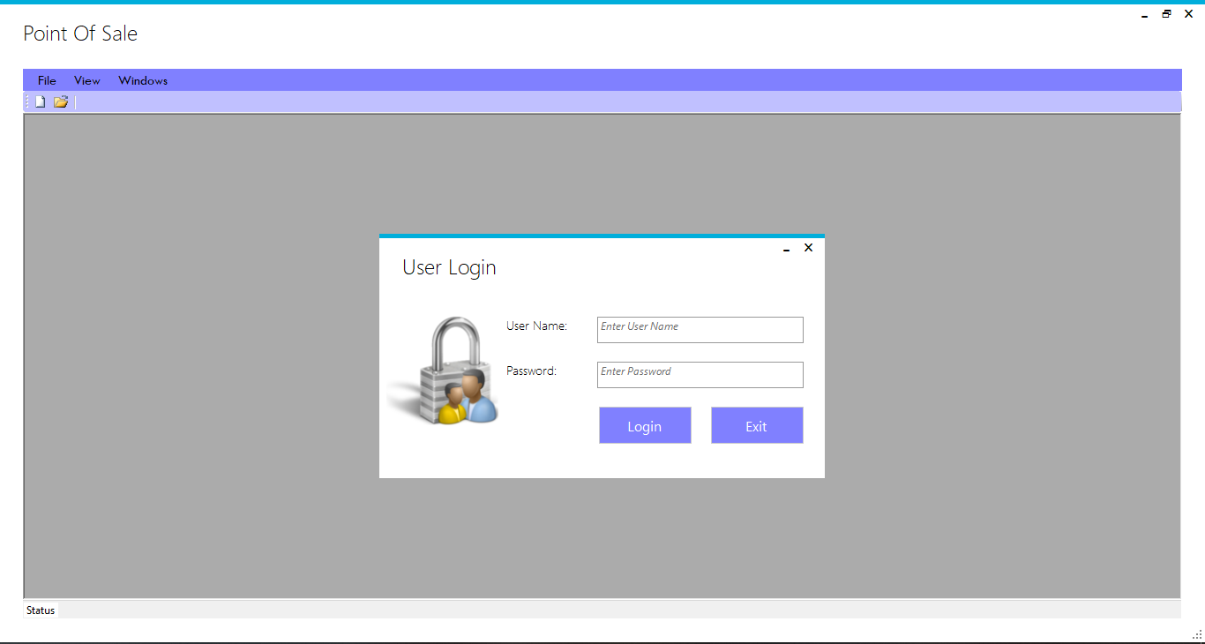

Admin Dashboard Form:

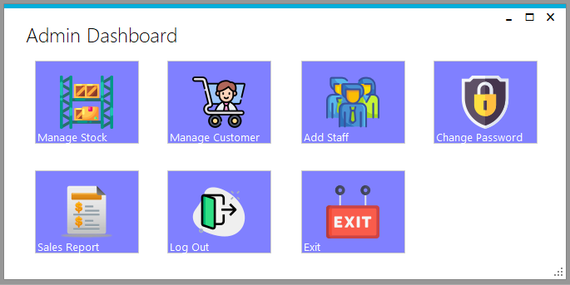

Manage Stock Form:

1. Add Product

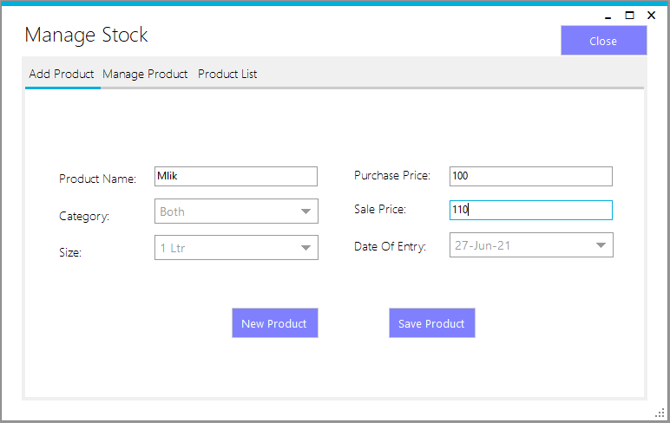

1. Update And Delete Product

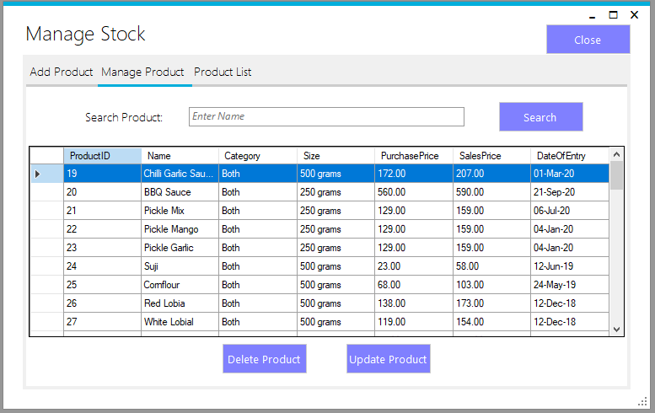

1. Delete Product

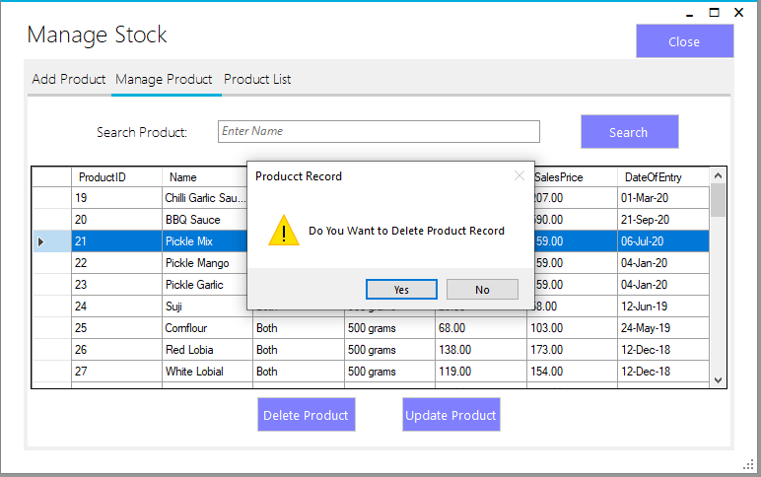

1. Update Product

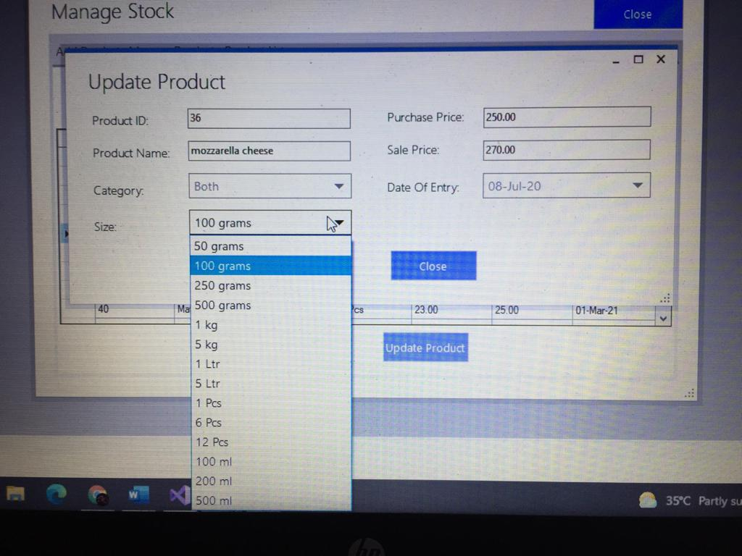

1. Products Report

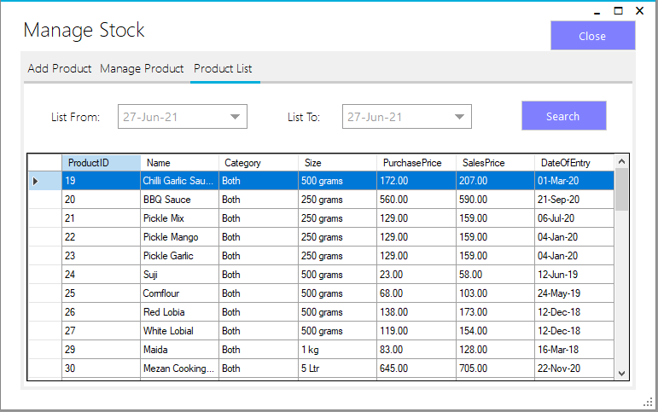

Manage Customer Form:

1. Add Customer

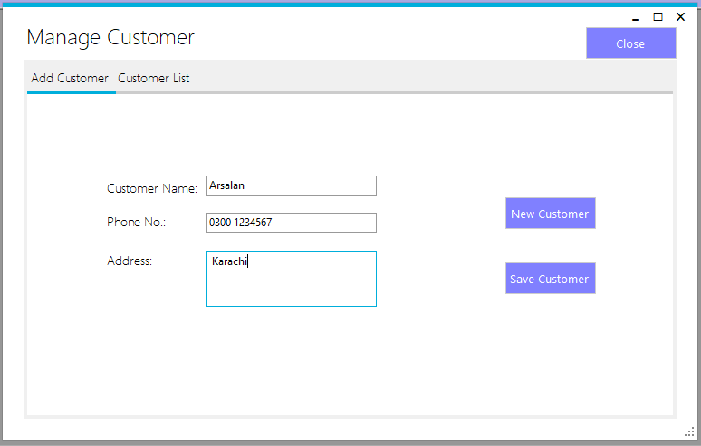

1. Customer Record

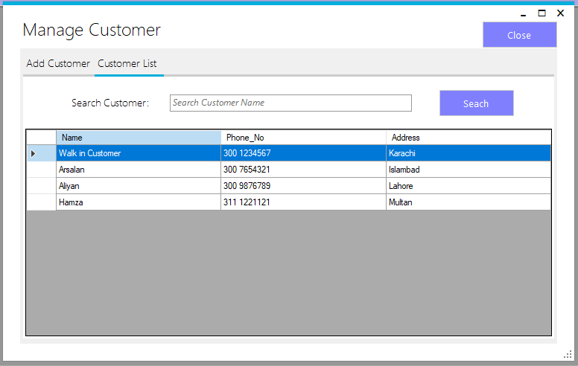

Add User From:

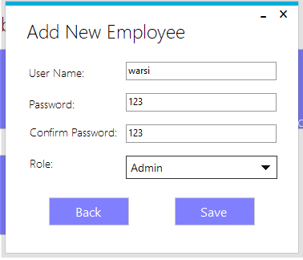

Change Password Form:

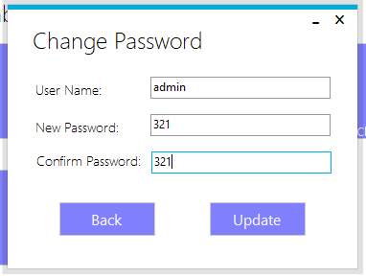

Sales Report Form:

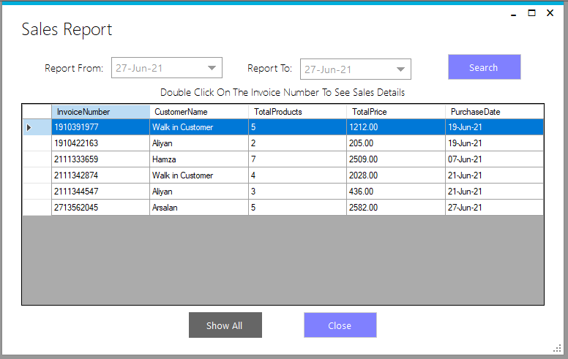

Sales Detail Form:

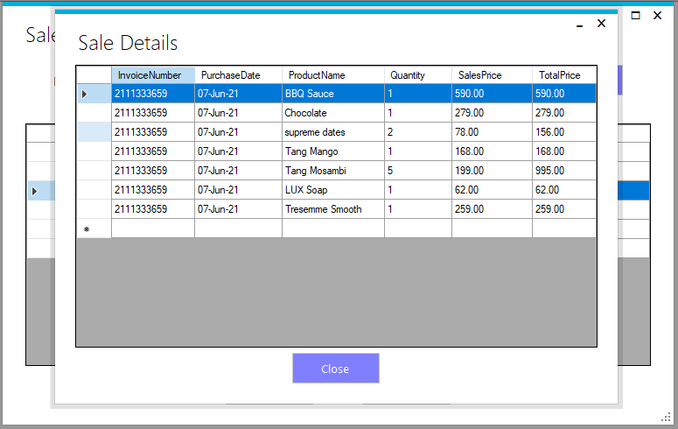

Staff Dashboard Form:

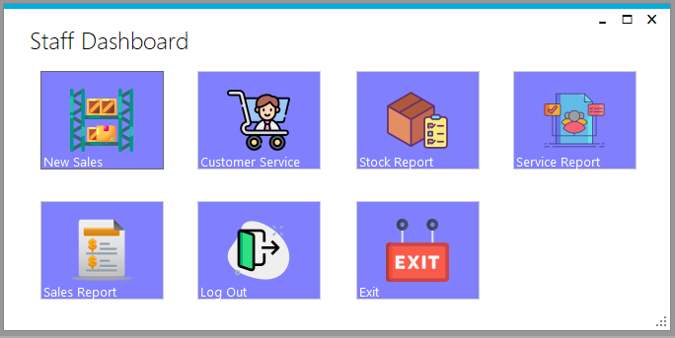

New Sales Form:

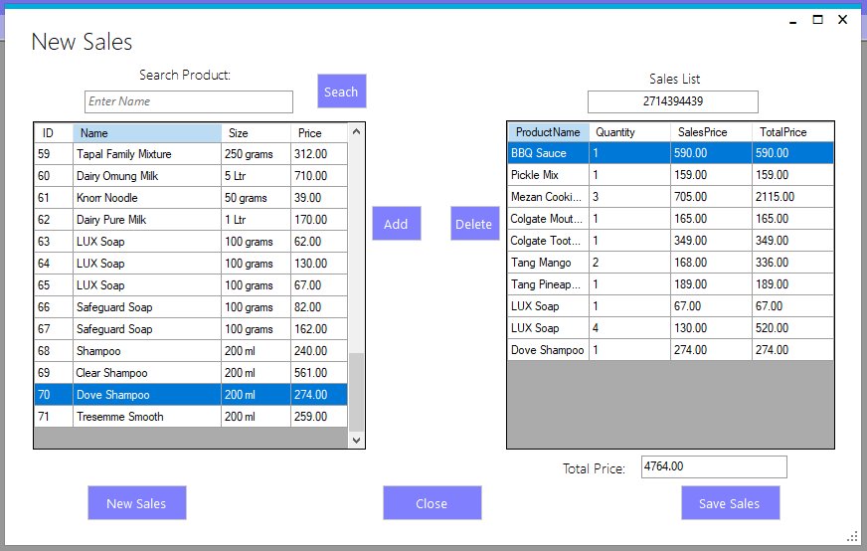

Save Sales Form:

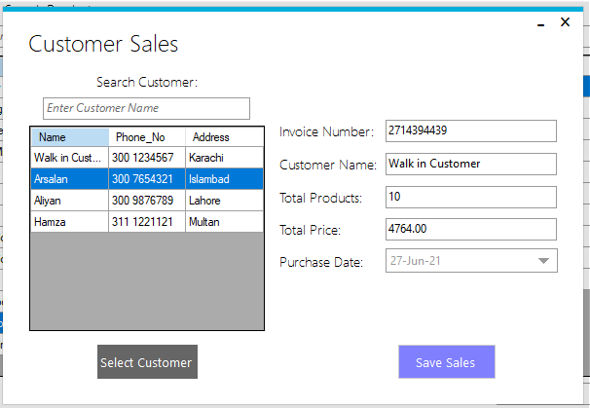

Sales Receipt:

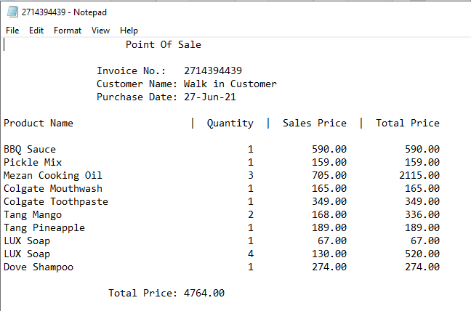

Customer Services Form:

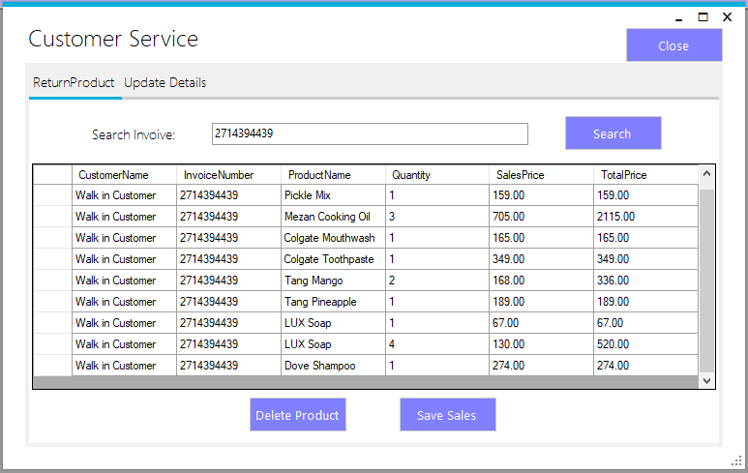

Update Customer Details Form:

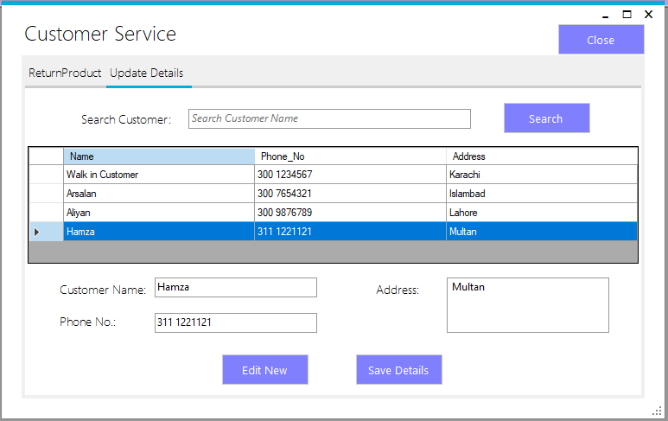

Stock Report Form:

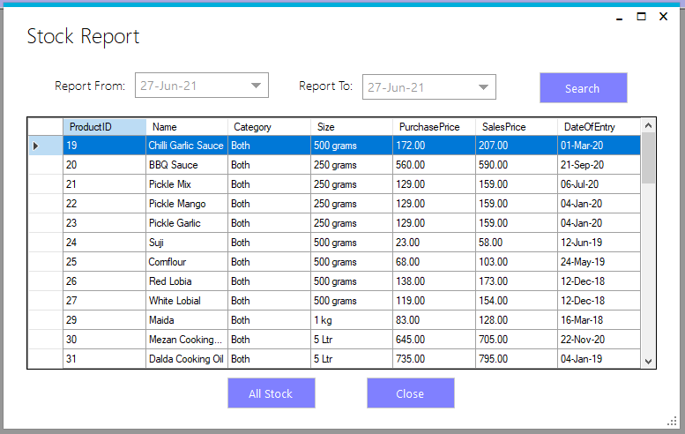

Services Record Form:

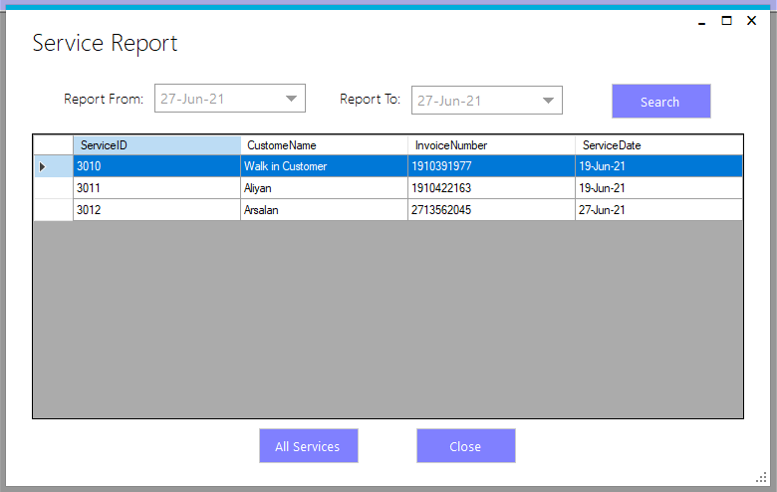

## Testing and Debugging:

**Test Case 1**

Test Title: User Login.

Test Procedure: Enter data and click login button.

Test Data: User need to enter username and password to login to system.

Expected Result: It will redirect to admin to admin dashboard and staff to staff dashboard.

**Test Case 2**

Test Title: Add Product

Test Procedure: Click add product button.

Test Data: Admin need to enter the details and click save button.

Expected Result: If the details are valid the record will be saved else error message will show.

**Test Case 3**

Test Title: Delete Product

Test Procedure: Click delete button.

Test Data: Admin need to select the product and then click delete button.

Expected Result: If the product is selected the product will delete from database.

**Test Case 4**

Test Title: Update Product

Test Procedure: Click Update button.

Test Data: Admin need to click update button and then enter the updates details and save button.

Expected Result: The product updated record will be saved.

**Test Case 5**

Test Title: Add Customer

Test Procedure: Click add customer button.

Test Data: Admin need to enter the details and click save button.

Expected Result: if the details are valid the record will be saved else error message will show.

**Test Case 6**

Test Title: Add Staff / Admin

Test Procedure: Click add staff button.

Test Data: Admin need to enter the details and click save button.

Expected Result: If the details are valid the record will be saved else error message will show.

**Test Case 7**

Test Title: Update Staff Password

Test Procedure: Click change button.

Test Data: Admin need to enter the username and password and click save button.

Expected Result: If the password and confirm password is valid the record will be saved else error message will show.

**Test Case 8**

Test Title: Sales Record

Test Procedure: Click sales button.

Test Data: Admin need to click sales button.

Expected Result: It will redirect the admin and staff to sales record form.

**Test Case 9**

Test Title: New Sales

Test Procedure: Click sales button.

Test Data: Staff need to click sales button and then add the products the customer wants the list will generate and hen click save sale button.

Expected Result: It will redirect the staff to save sales record form and save the data and generate the receipt.

**Test Case 10**

Test Title: Customer Services

Test Procedure: Click service button.

Test Data: Staff need to click service button and then enter the invoice number to see the sales list. The products can be deleted and save the sales to provide the service to the customer.

Expected Result: It will save the service record in the database.

**Test Case 11**

Test Title: Customer Services

Test Procedure: Click service button.

Test Data: Staff need to click service button and then select the customer to update the details of the customer.

Expected Result: The update details of the customer will be record in the database.

**Test Case 12**

Test Title: Service Record

Test Procedure: Click service record button.

Test Data: staff need to click service record button.

Expected Result: It will redirect the staff to service record form.

**CONCLUSION**

## Project Limitations:

The Point-of-Sale Management System has some limitation too:

* The system only allows to sale the product to customer if the product is not expired.
* The system should be complete within 2 to 3 months.
* The system should be developed in C# language only.
* The system should support the different brands equipment’s (bar code scanner, printer and payment terminal machine) that are used to operate it.
* The system should generate the sales receipt whenever the sales is done and save that transection in the database accurately.
* Exclude the quantity of the products form the store inventory that have been sold to managed the inventory.

## Conclusions:

This system helps to manage stock, customer, staff the system is also capable to generate the reports like stock, customer, sales, services. The system helps to reduce the employee's cost to who are working on the above defined tasks and also save the time to manage the tings without any human error.

## Future Directions:

In the future direction we can assume that most restaurants, stores will use our system because it uses to manage this thing without involving many people. The report can be easily generated with just one click which helps in future decision making which is very beneficial for any business.

REFERENCES

<https://www.researchgate.net/figure/s-the-future-use-case-diagram-for-the-new-system-which-shows-the-addition-of-a-new-actor_fig6_319410608>

<https://www.tutorialspoint.com/vb.net/vb.net_combobox.htm>

<https://www.youtube.com/watch?v=yif7vJf6YGk&ab_channel=ProgrammingforEverybody>